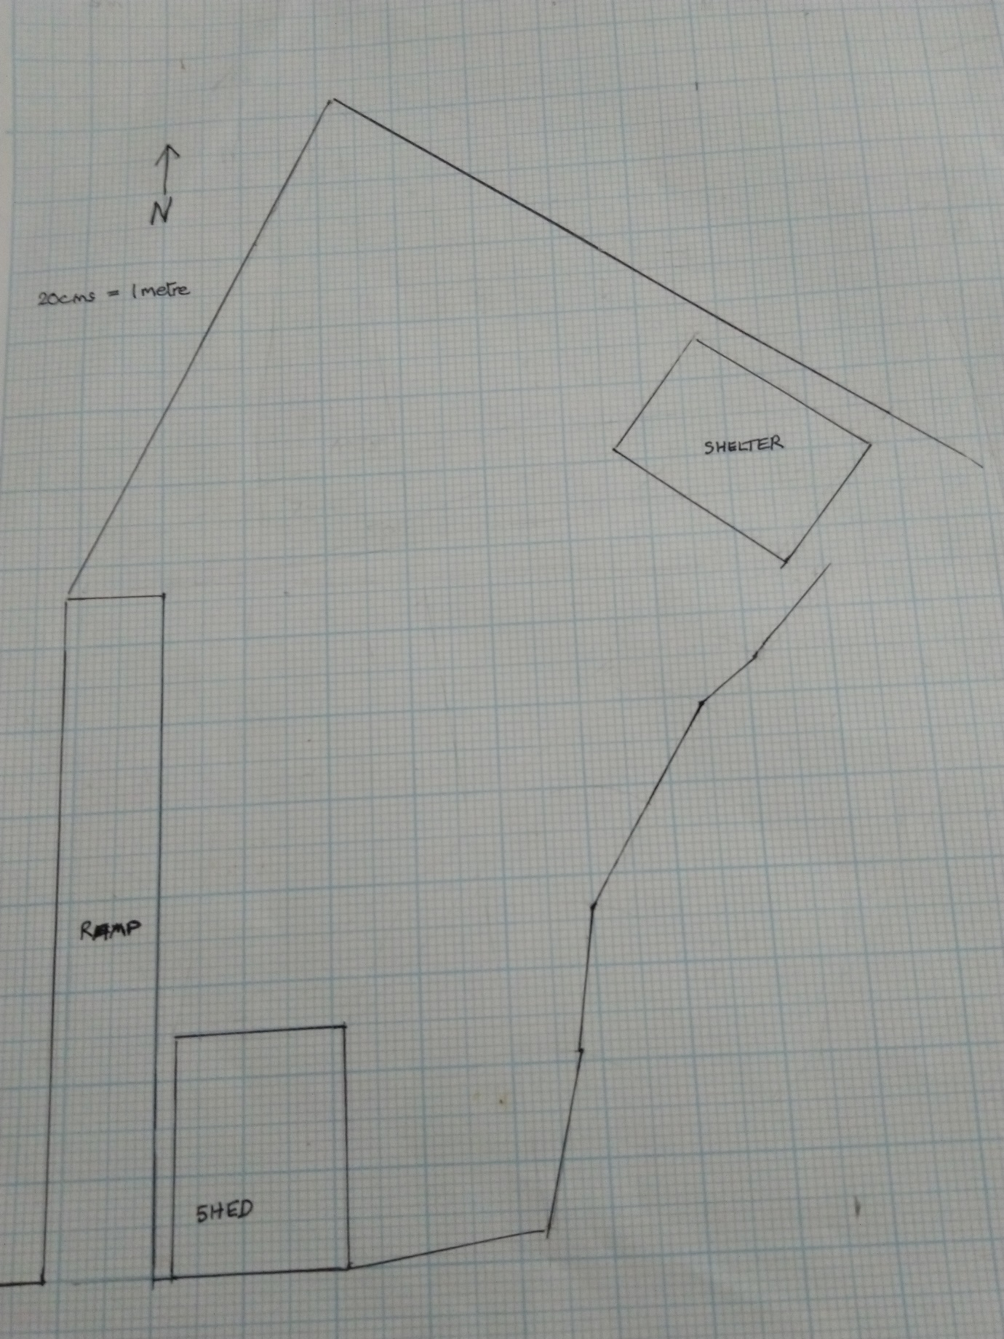

This blue square = 1 square metre in the garden.

The WW2 Garden